**KIRUHURA DISTRICT APPROVED SHS.31.9 BILLION BUDGET FOR 2025/2026 FINANCIAL YEAR**

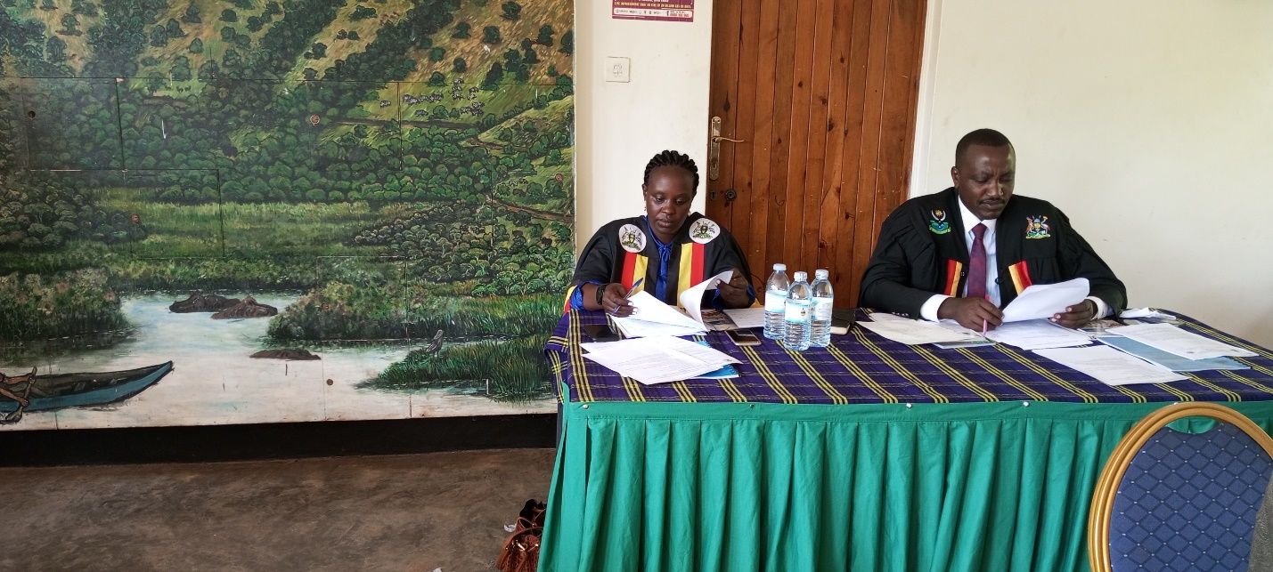

**Kiruhura District Council in Session discussing draft budget estimates & Work plan FY 2025/2026**

In a bid to realize the district vision of attaining holistic sustainable development and poverty free communities by 2030, Kiruhura District Council in its 17th Council session approved budget and work plan worth Ug. Shs. 31,908,721,000 for the financial year 2025/2026.

The total expenditure budget is Ug. Shs. 31,908,271,000 out of which wage is Shs. 17,829,233,000 which is 55% of the total budget, non-wage recurrent is Shs.9,090,407,000 which is 28.5% of the total budget, domestic development Shs.3,966,156,000 which is 12.4% of the total budget and external financing Shs. 1,022,925,00 which is 3.2% of the total budget.

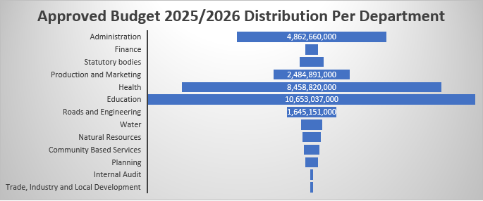

The Production and Marketing department budgeted for procurement and supply of 4 motorcycles, 3 laptops, laboratory kits, apiary kits, one Technology Demonstration structures (TDS) to demonstrate high milk yield, Technology Demonstration structures (TDS) on coffee, expansion of feed facilities of zero grazing unit, replacement of dam liner at mother garden.

The health department has budgeted for Completion of fencing of Kiruhura HCIV and provision of a gate’s man shelter, Completion of staff house construction at Kiruhura HCIV (Phase 2), procurement of ultra sound scan for Kiruhura HC IV, fencing of the District medical store and installation of Security spy cameras, installation of solar on the staff house at Kiruhura HC IV and Rurambiira HCIII, Replacement of Solar system at DHOs office, Procurement of ICT equipment for Health Facilities and renovation of District Health Office. The Ministry of Health provided UGX 975,847,325/= for extra works to furnish the 5 health facilities upgraded under UGIFT Project namely: Kitura HCIII, Rweshande HCIII, Nshwere HCIII, Rwetamu HCIII and Rwabarata HCIII.

The education department budgeted for construction of two classroom blocks at Kitabo PS, Ryakyenda PS and Keikoti PS. Renovation of Mooya Catholic, Kaku, Karengo Parents, Birunduma, Rwengiri, Kashongi Junior, Mitooma II, Kakagate, Akatenga, Bweeza, Kyabagyenyi, Mabaare, Akabare, Kashwa, Katete, Ruhengyere, Butembererwa, Kabushwere, Mbuga primary schools.

The water department planned for the Construction of a solar powered water system at Rwemikunyu, Construction of 2 rain water harvesting tanks at Kyeera Catholic Church and St Peters Secondary School, Construction of a public latrine Rugaaga RGC in Kikatsi SC, Rehabilitation of boreholes in Kinoni and Nyakashashara.

The Natural Resources department budgeted for preparation of land titles for 7 pieces of government lands Nyakashashara sc land, Rwobuziizi dam, Kanyaryeru HC III, Kanyaryeru PS, Rurambira HC III, Nyakashashara PS and Kanyaryeru Sc headquarters. Establishment of a nursery Bed at the district HQ and 165 concrete pillars.

During the FY 2025/26, the Roads and Engineering department planned for maintenance of 249.6 Kilometres of earth road across the district, construction of Administration Block (Phase IV) and fencing of the district headquarters.

Hon. Asiimwe Rogers, the Secretary for Finance, Planning and Administration said the estimated revenue increased by 4.5% compared with that of FY2024/2025. According to the approved budget, Education, Health, Production and Marketing department had the biggest share of the budget with the focus of impacting on social service delivery.

Mukago Dan. Rutetebya, the District Chairperson urged the people of Kiruhura District to give total support to the district on order to live our dream of having a prosperous district. The theme for the Budget for the FY 2025/2026 is *“Full monetisation of the Uganda economy through commercial agriculture, industrialisation, expanding and broadening services, digital transformation and market access”.*

**END!**

**The writer is a Senior Communication Officer – Kiruhura District**